**Introduction**

In this short report, I will be explaining what tools and techniques I used to create my website. I will show screenshots of the pages and the coding within the webpage. I will also finalise this report by evaluating the website.

Development process

Before starting my webpage, I was inspired by the NFL.com page. The colours are function were very extravagant which gave me and idea of what website I wanted to create. Before starting the webpage, I sketched out a few drawings of the prototype would look like. The sketches can be found in the Readme file. Below I will post the NFL website annotating the features, functions and colours and styles I enjoyed.

[1]

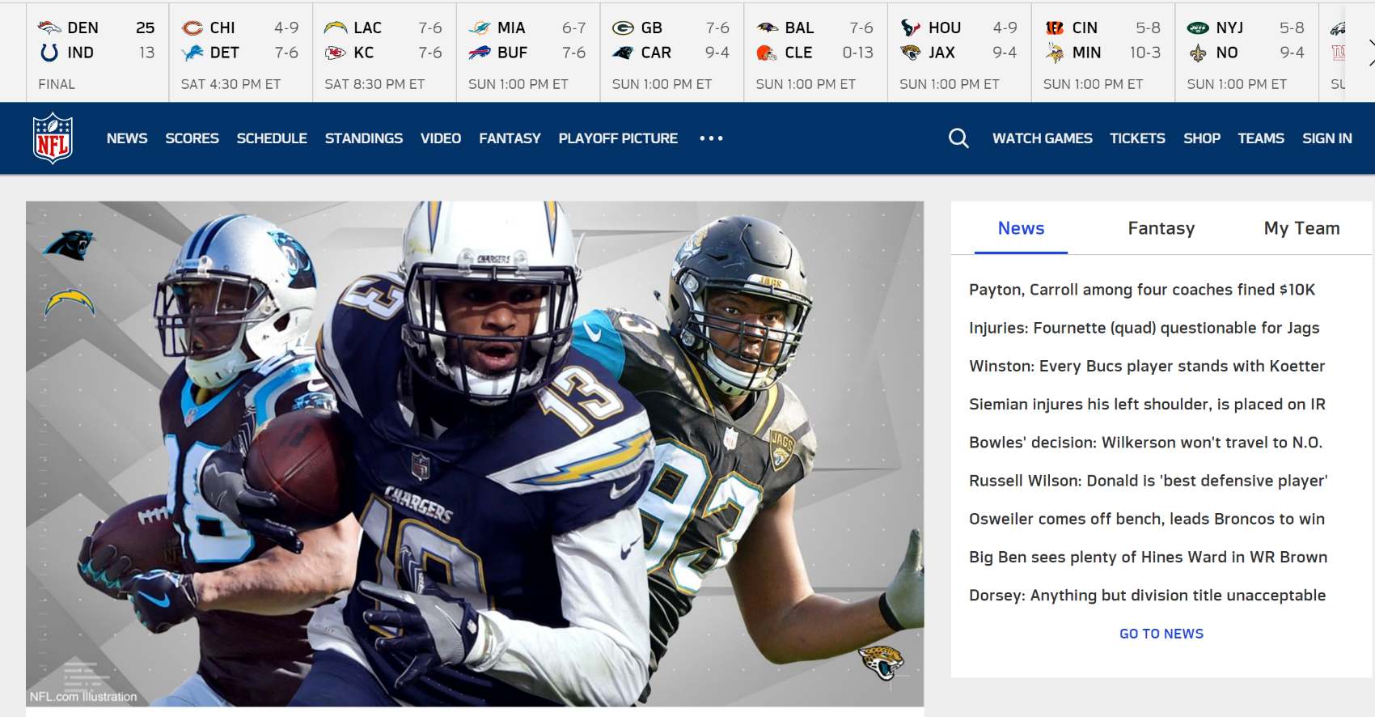

The NFL Logo tells us the owner of the website which is the “National Football League”. The logo has bright and outstanding colours which appeal to the target audience. The image tells us the top plays of the NFL currently at their best and the upcoming games they have. The image used has 3 team logos, which tells us what team each player plays for. The yellow is the navigation bar that has news, shops, tickets and the latest scores. It also has a search function to be able to search anything about the sport or the league. This part shows a short tab with the latest news. When a thread is clicked by a user the news will expand onto another page.

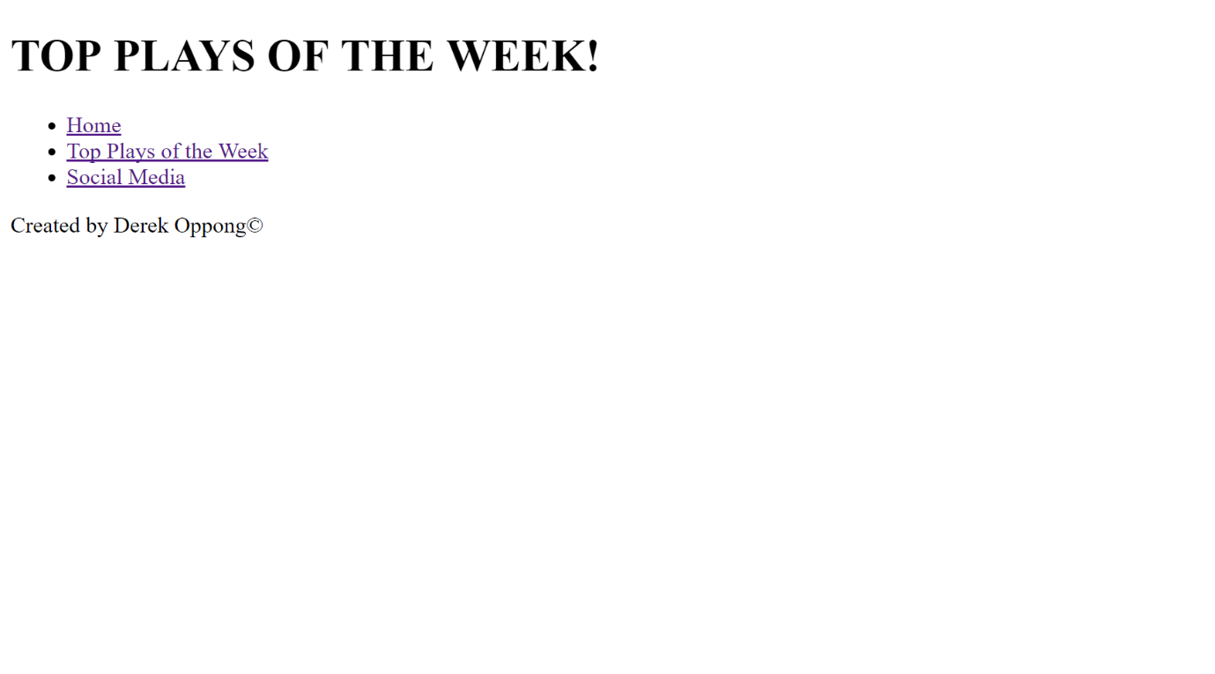**Prototype/ WireFrame**

This is the wireframe of the website, it includes the navigation bar, the header and the footer. The pages are all linked in the read me file.

**My Website**

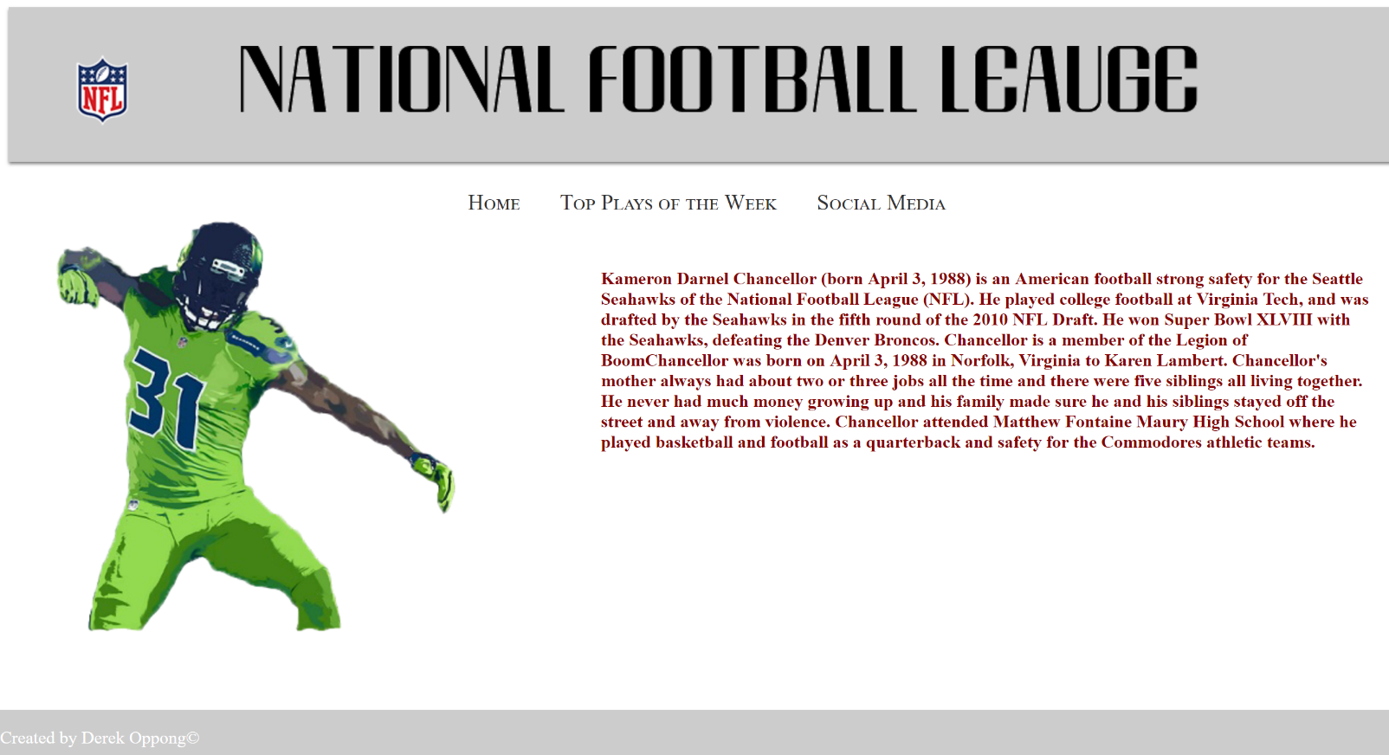Page #1

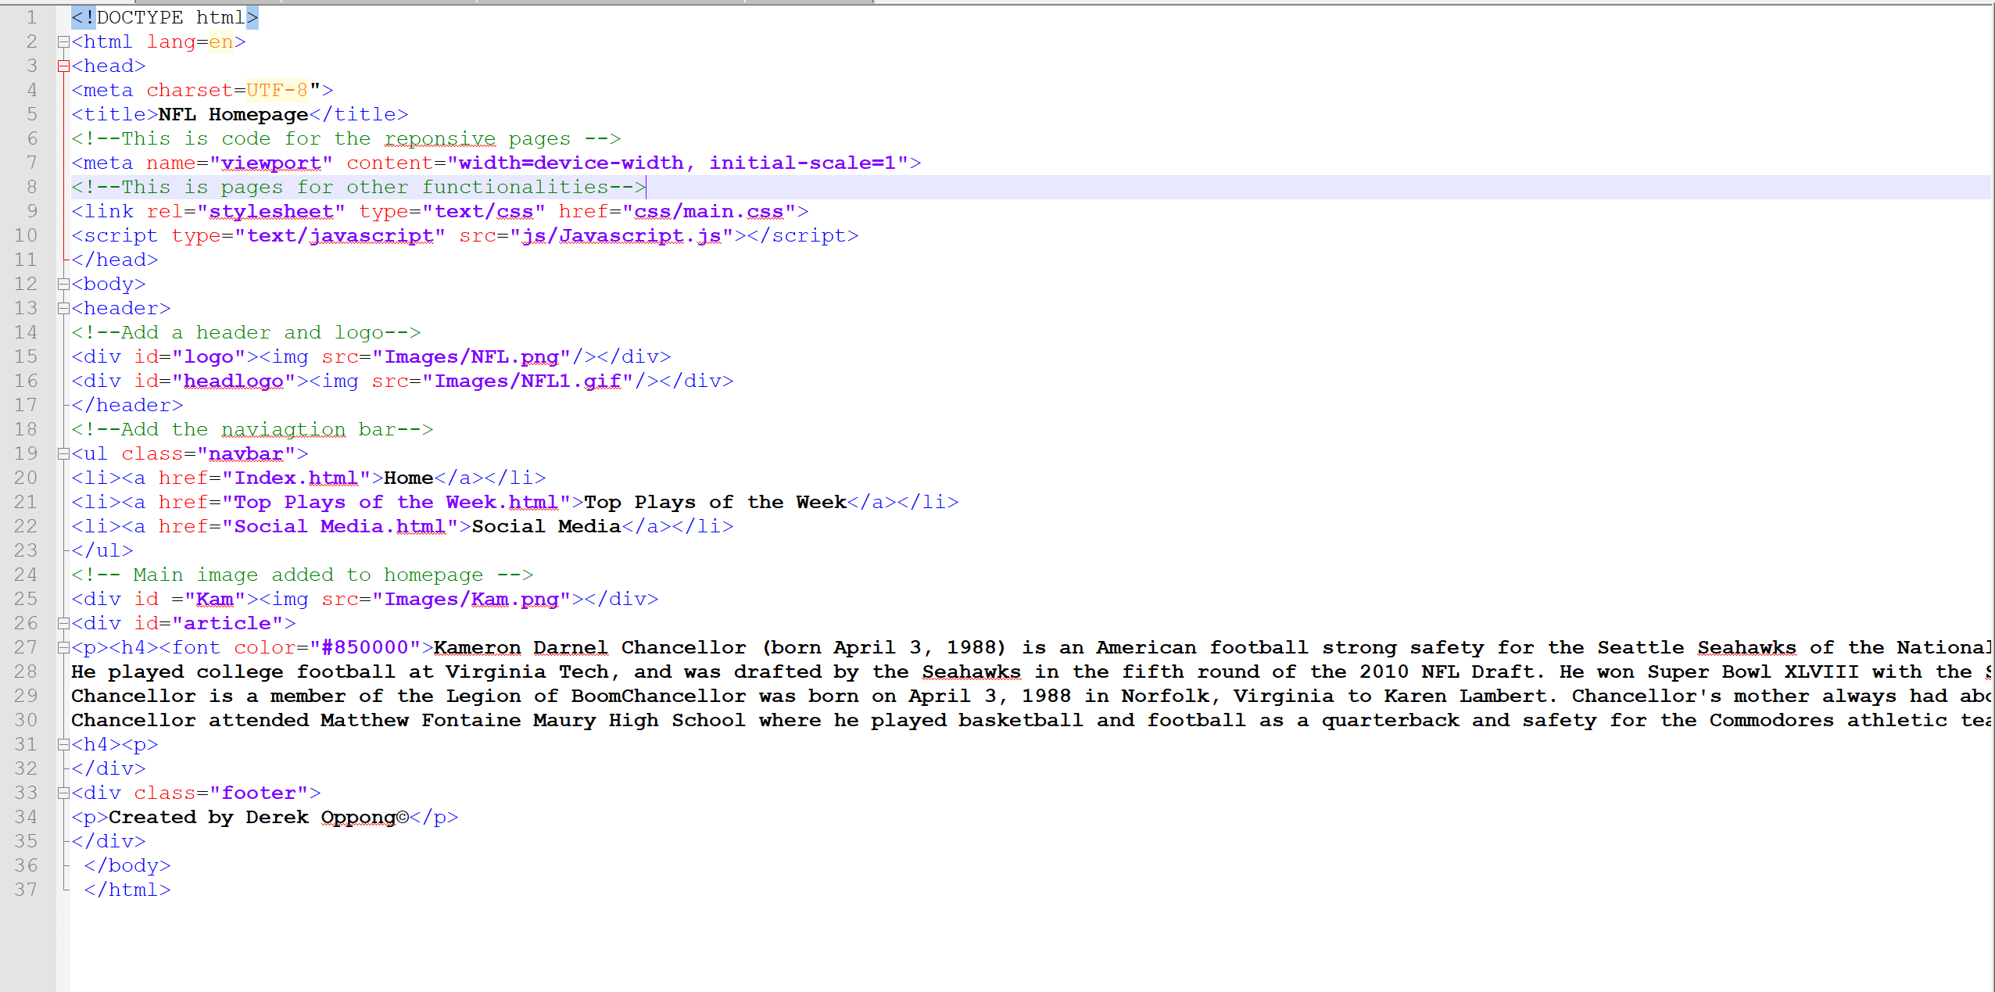Coding

Issues solved

Code comments

1.